**IBM Hack Challenge 2022 - Code For A Better Future (Smart Internz)**

**Problem Statement: Applying AI to Help people improve their lifestyle**

**Project: Disease Prediction**

**INTRODUCTION**

* 1. **Overview**
* The system processes the symptoms provided by the user as input and gives the output as the probability of the disease. So that doctor can treat patients without physical touch.
  1. **Purpose**
* Disease Prediction system is based on predictive modeling predicts the disease of the user on the basis of the symptoms that user provides as an input to the system. The system analyzes the symptoms provided by the user as input and gives the probability of the disease Asian output Disease Prediction is done by implementing the NaiveiBayes Classifier. Naive Bayes Classifier calculates the probability of the disease. With big data growth in biomedical and health care communities, accurate analysis of medical data benefits early disease detection, patient care. By using linear regression and decision tree we are predicting diseases like Diabetes, Malaria, Jaundice, Dengue, and Tuberculosis.

**LITERATURE SURVEY**

**2.1 Existing problem**

* The value of machine learning is rooted in its ability to create accurate models for disease predication to guide future actions and to discover patterns that we've never seen before.

**2.2 Propose solution**

* Machine Learning is an emerging approach that helps in prediction, diagnosis of a disease. This paper depicts the prediction of disease based on symptoms using machine learning. Machine Learning algorithms such as Naive Bayes, Decision Tree and Random Forest are employed on the provided dataset and predict the disease.

**3 THEORITICAL ANALYSIS**

**3.1 Block Diagram**

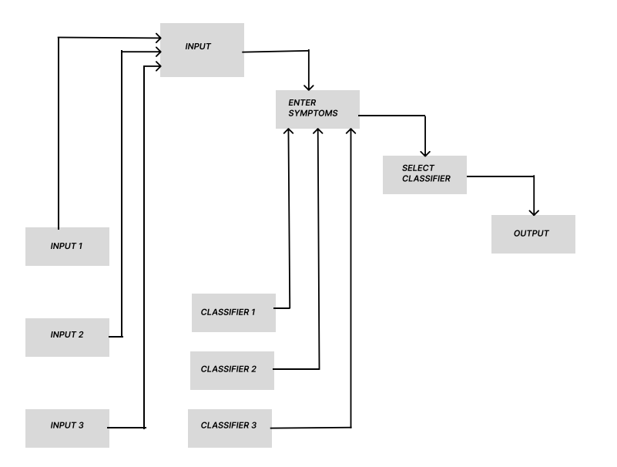

**3.2 Hardware / Software designing**

|  |  |
| --- | --- |
| **Component** | **Minimum Requirement** |
| Processor | 64-bit, four-core, 2.5 GHz minimum per core |
| RAM | 8 GB for developer and evaluation use |
| Hard Disk | 256 GB |
| SSD | 256 GB |

**4. Experimental Investigations**

* A observation was carried out that, the people are not always completely assured about the disease they are suffering from. They sometimes misunderstood the symptoms they have. And nowadays some doctors have a greed of money due to which they charge unnecessarily o their patient. Due to this reason financially weaker people sometimes have to suffer a lot. So, to overcome such issues we have come up with our idea.

**5. Flowchart**

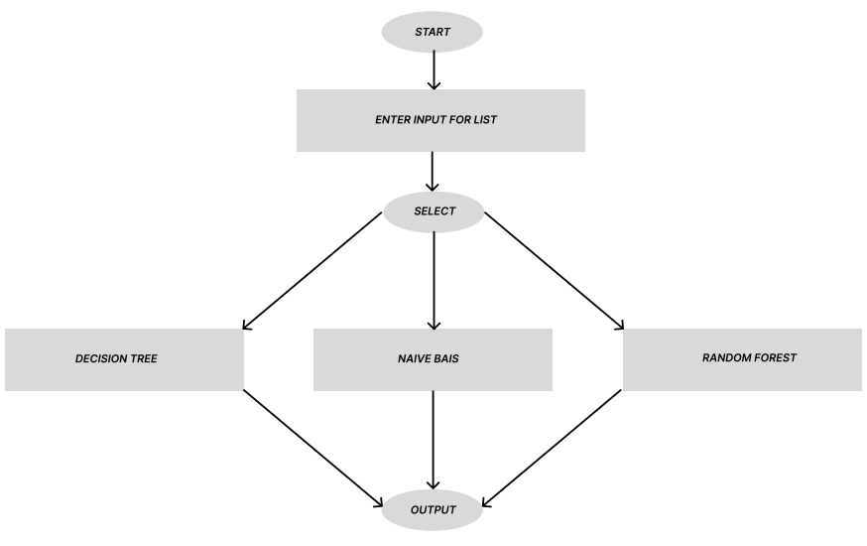

**6. Result**

**Output:** Various Symptoms showing

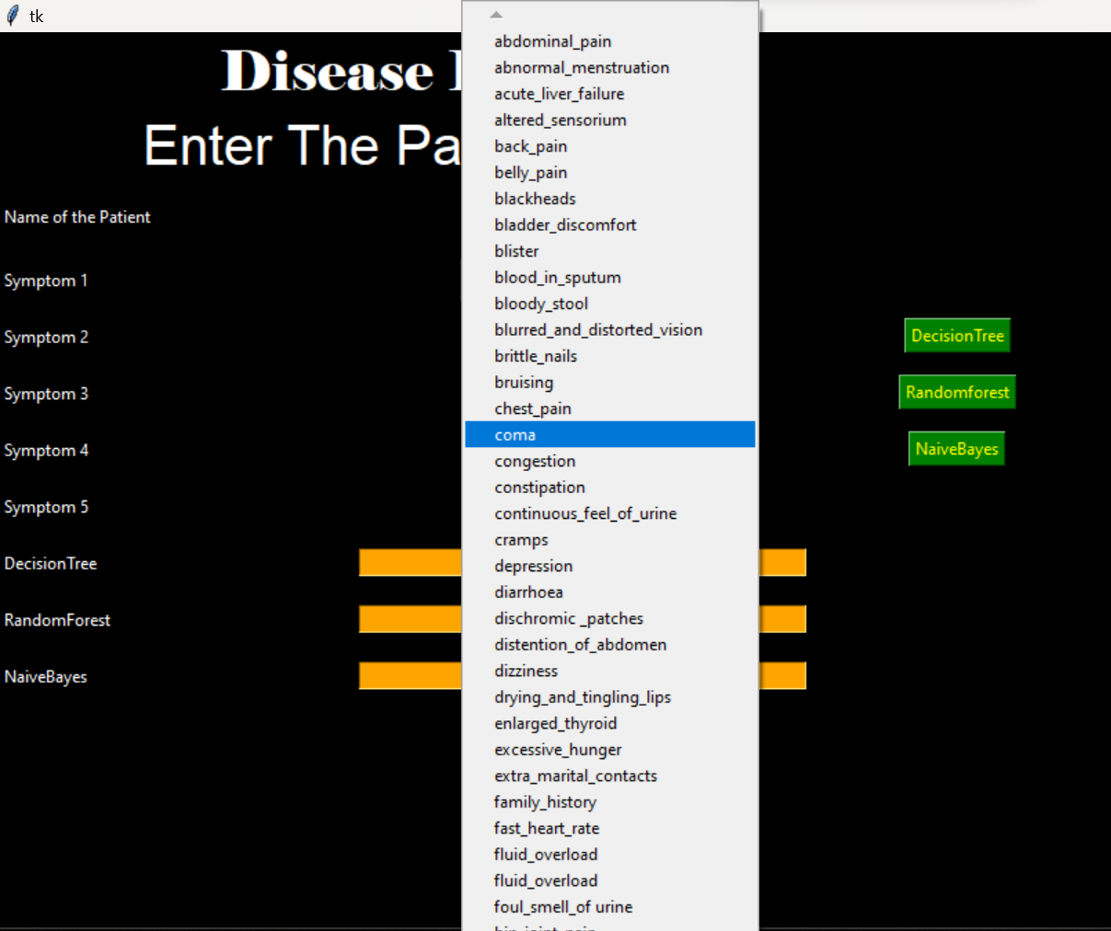

Various Symptoms showing

**Output:** Test Case-1

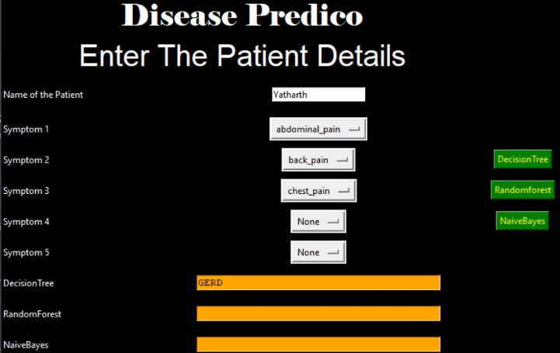

Fig:1.1 - Using DecisionTree Algorithm

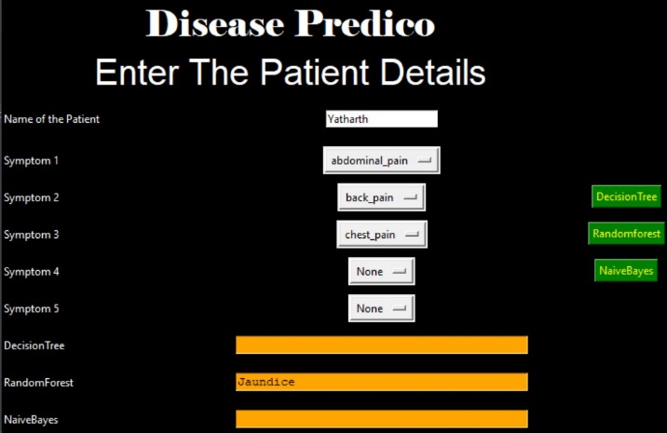

Fig:1.2 - Using RandomForest Algorithm

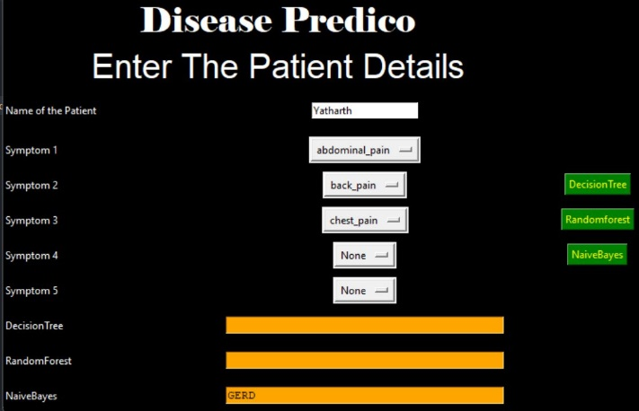

Fig:1.3 - Using NaiveBayes Algorithm

**Output:** Test Case-2

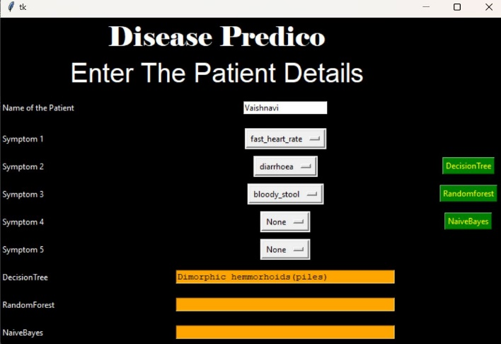

Fig:2.1 - Using DecisionTree Algorithm

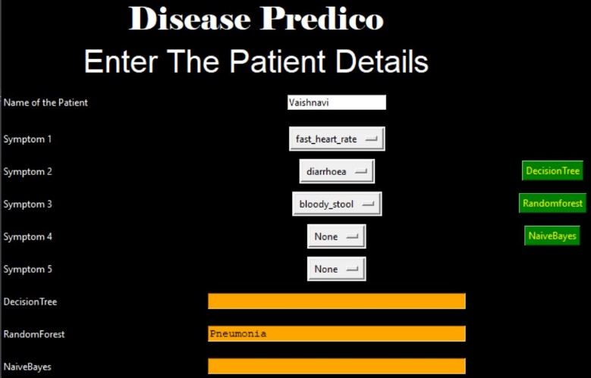

Fig:2.2 - Using RandomForest Algorithm

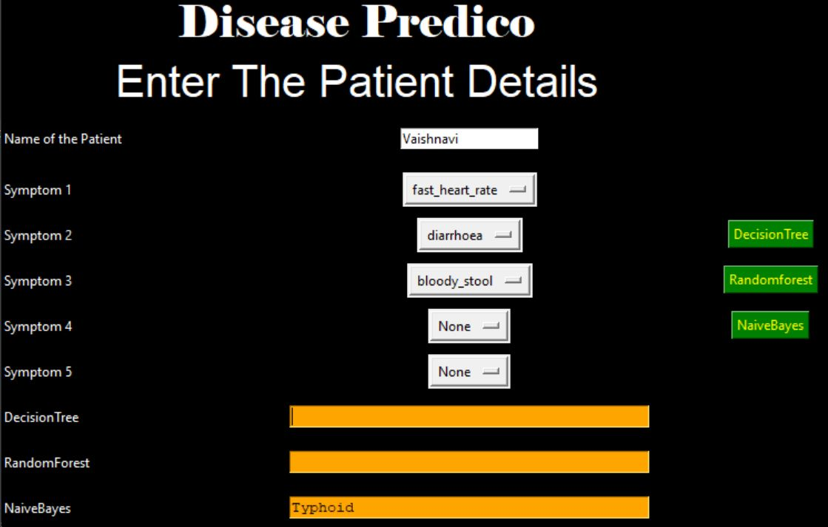

Fig:2.3 - Using NaiveBayes Algorithm

**7. Advantages & Disadvantages**

**Advantages:**

* It can identify patients at risk of disease or health conditions.
* Increased accuracy for effective disease diagnosis.
* Handles roughest(enormous) amount of data using DecisionTree, randomforest and NaiveBayes algorithm and feature selection.
* Reduce the time complexity of doctors.
* Cost effective for patients.

**Disadvantages:**

* Cannot have datasets for patient records.
* Not Providing any medicines details regarding symptoms.
* Maybe patient confused to showing three types of result.

**8. Applications:**

* The Data is used when planning how to control and prevent disease in the community.
* Model has been used to figured out Symptoms anywhere doesn’t matter.
* Public health center
* Health services research
* During Medical Studies

**9. Conclusion:**

* Concluding, we would like to add that health is wealth, healthy min in healthy body. So, health is much essential in one’s life. One should be aware of the symptoms if he/she is suffering from. Delaying it might cause a severe effects in future. Hence, rapid action must be taken.

**10. Future Scope**

* In the upcoming future health is going to be a major issue. We also observe that some diseases can transmit through physical contact also. Sometimes when doctor checks us, this might happen that the disease of patient who came before you, might be transferred to your body as well. Hence care should be taken. So, due to this reason our project idea will overcome this issue.
* We will try to collaborate with the hospitals for this. A small change will definitely save lots of lives.

**11. Bibilography**

* None. Whole project is made from scratch.

**APPENDIX**

1. **Souce Code**

from tkinter import *  
import numpy as np  
import pandas as pd  
# from gui_stuff import *  
  
l1=['back_pain','constipation','abdominal_pain','diarrhoea','mild_fever','yellow_urine',  
'yellowing_of_eyes','acute_liver_failure','fluid_overload','swelling_of_stomach',  
'swelled_lymph_nodes','malaise','blurred_and_distorted_vision','phlegm','throat_irritation',  
'redness_of_eyes','sinus_pressure','runny_nose','congestion','chest_pain','weakness_in_limbs',  
'fast_heart_rate','pain_during_bowel_movements','pain_in_anal_region','bloody_stool',  
'irritation_in_anus','neck_pain','dizziness','cramps','bruising','obesity','swollen_legs',  
'swollen_blood_vessels','puffy_face_and_eyes','enlarged_thyroid','brittle_nails',  
'swollen_extremeties','excessive_hunger','extra_marital_contacts','drying_and_tingling_lips',  
'slurred_speech','knee_pain','hip_joint_pain','muscle_weakness','stiff_neck','swelling_joints',  
'movement_stiffness','spinning_movements','loss_of_balance','unsteadiness',  
'weakness_of_one_body_side','loss_of_smell','bladder_discomfort','foul_smell_of urine',  
'continuous_feel_of_urine','passage_of_gases','internal_itching','toxic_look_(typhos)',  
'depression','irritability','muscle_pain','altered_sensorium','red_spots_over_body','belly_pain',  
'abnormal_menstruation','dischromic _patches','watering_from_eyes','increased_appetite','polyuria','family_history','mucoid_sputum',  
'rusty_sputum','lack_of_concentration','visual_disturbances','receiving_blood_transfusion',  
'receiving_unsterile_injections','coma','stomach_bleeding','distention_of_abdomen',  
'history_of_alcohol_consumption','fluid_overload','blood_in_sputum','prominent_veins_on_calf',  
'palpitations','painful_walking','pus_filled_pimples','blackheads','scurring','skin_peeling',  
'silver_like_dusting','small_dents_in_nails','inflammatory_nails','blister','red_sore_around_nose',  
'yellow_crust_ooze']  
  
disease=['Fungal infection','Allergy','GERD','Chronic cholestasis','Drug Reaction',  
'Peptic ulcer diseae','AIDS','Diabetes','Gastroenteritis','Bronchial Asthma','Hypertension',  
' Migraine','Cervical spondylosis',  
'Paralysis (brain hemorrhage)','Jaundice','Malaria','Chicken pox','Dengue','Typhoid','hepatitis A',  
'Hepatitis B','Hepatitis C','Hepatitis D','Hepatitis E','Alcoholic hepatitis','Tuberculosis',  
'Common Cold','Pneumonia','Dimorphic hemmorhoids(piles)',  
'Heartattack','Varicoseveins','Hypothyroidism','Hyperthyroidism','Hypoglycemia','Osteoarthristis',  
'Arthritis','(vertigo) Paroymsal Positional Vertigo','Acne','Urinary tract infection','Psoriasis',  
'Impetigo']  
  
l2=[]  
for x in range(0,len(l1)):  
 l2.append(0)  
  
# TESTING DATA df -------------------------------------------------------------------------------------  
df=pd.read_csv("Training.csv")  
  
df.replace({'prognosis':{'Fungal infection':0,'Allergy':1,'GERD':2,'Chronic cholestasis':3,'Drug Reaction':4,  
'Peptic ulcer diseae':5,'AIDS':6,'Diabetes ':7,'Gastroenteritis':8,'Bronchial Asthma':9,'Hypertension ':10,  
'Migraine':11,'Cervical spondylosis':12,  
'Paralysis (brain hemorrhage)':13,'Jaundice':14,'Malaria':15,'Chicken pox':16,'Dengue':17,'Typhoid':18,'hepatitis A':19,  
'Hepatitis B':20,'Hepatitis C':21,'Hepatitis D':22,'Hepatitis E':23,'Alcoholic hepatitis':24,'Tuberculosis':25,  
'Common Cold':26,'Pneumonia':27,'Dimorphic hemmorhoids(piles)':28,'Heart attack':29,'Varicose veins':30,'Hypothyroidism':31,  
'Hyperthyroidism':32,'Hypoglycemia':33,'Osteoarthristis':34,'Arthritis':35,  
'(vertigo) Paroymsal Positional Vertigo':36,'Acne':37,'Urinary tract infection':38,'Psoriasis':39,  
'Impetigo':40}},inplace=True)  
  
  
  
X= df[l1]  
  
y = df[["prognosis"]]  
np.ravel(y)  
# print(y)  
  
# TRAINING DATA tr --------------------------------------------------------------------------------  
tr=pd.read_csv("Testing.csv")  
tr.replace({'prognosis':{'Fungal infection':0,'Allergy':1,'GERD':2,'Chronic cholestasis':3,'Drug Reaction':4,  
'Peptic ulcer diseae':5,'AIDS':6,'Diabetes ':7,'Gastroenteritis':8,'Bronchial Asthma':9,'Hypertension ':10,  
'Migraine':11,'Cervical spondylosis':12,  
'Paralysis (brain hemorrhage)':13,'Jaundice':14,'Malaria':15,'Chicken pox':16,'Dengue':17,'Typhoid':18,'hepatitis A':19,  
'Hepatitis B':20,'Hepatitis C':21,'Hepatitis D':22,'Hepatitis E':23,'Alcoholic hepatitis':24,'Tuberculosis':25,  
'Common Cold':26,'Pneumonia':27,'Dimorphic hemmorhoids(piles)':28,'Heart attack':29,'Varicose veins':30,'Hypothyroidism':31,  
'Hyperthyroidism':32,'Hypoglycemia':33,'Osteoarthristis':34,'Arthritis':35,  
'(vertigo) Paroymsal Positional Vertigo':36,'Acne':37,'Urinary tract infection':38,'Psoriasis':39,  
'Impetigo':40}},inplace=True)  
  
X_test= tr[l1]  
y_test = tr[["prognosis"]]  
np.ravel(y_test)  
# ------------------------------------------------------------------------------------------------------  
  
def DecisionTree():  
  
 from sklearn import tree  
  
 clf3 = tree.DecisionTreeClassifier() # empty model of the decision tree  
 clf3 = clf3.fit(X,y)  
  
 # calculating accuracy-------------------------------------------------------------------  
 from sklearn.metrics import accuracy_score  
 y_pred=clf3.predict(X_test)  
 print(accuracy_score(y_test, y_pred))  
 print(accuracy_score(y_test, y_pred,normalize=False))  
 # -----------------------------------------------------  
  
 psymptoms = [Symptom1.get(),Symptom2.get(),Symptom3.get(),Symptom4.get(),Symptom5.get()]  
  
 for k in range(0,len(l1)):  
 # print (k,)  
 for z in psymptoms:  
 if(z==l1[k]):  
 l2[k]=1  
  
 inputtest = [l2]  
 predict = clf3.predict(inputtest)  
 predicted=predict[0]  
  
 h='no'  
 for a in range(0,len(disease)):  
 if(predicted == a):  
 h='yes'  
 break  
  
  
 if (h=='yes'):  
 t1.delete("1.0", END)  
 t1.insert(END, disease[a])  
 else:  
 t1.delete("1.0", END)  
 t1.insert(END, "Not Found")  
  
  
def randomforest():  
 from sklearn.ensemble import RandomForestClassifier  
 clf4 = RandomForestClassifier()  
 clf4 = clf4.fit(X,np.ravel(y))  
  
 # calculating accuracy-------------------------------------------------------------------  
 from sklearn.metrics import accuracy_score  
 y_pred=clf4.predict(X_test)  
 print(accuracy_score(y_test, y_pred))  
 print(accuracy_score(y_test, y_pred,normalize=False))  
 # -----------------------------------------------------  
  
 psymptoms = [Symptom1.get(),Symptom2.get(),Symptom3.get(),Symptom4.get(),Symptom5.get()]  
  
 for k in range(0,len(l1)):  
 for z in psymptoms:  
 if(z==l1[k]):  
 l2[k]=1  
  
 inputtest = [l2]  
 predict = clf4.predict(inputtest)  
 predicted=predict[0]  
  
 h='no'  
 for a in range(0,len(disease)):  
 if(predicted == a):  
 h='yes'  
 break  
  
 if (h=='yes'):  
 t2.delete("1.0", END)  
 t2.insert(END, disease[a])  
 else:  
 t2.delete("1.0", END)  
 t2.insert(END, "Not Found")  
  
  
def NaiveBayes():  
 from sklearn.naive_bayes import GaussianNB  
 gnb = GaussianNB()  
 gnb=gnb.fit(X,np.ravel(y))  
  
 # calculating accuracy-------------------------------------------------------------------  
 from sklearn.metrics import accuracy_score  
 y_pred=gnb.predict(X_test)  
 print(accuracy_score(y_test, y_pred))  
 print(accuracy_score(y_test, y_pred,normalize=False))  
 # -----------------------------------------------------  
  
 psymptoms = [Symptom1.get(),Symptom2.get(),Symptom3.get(),Symptom4.get(),Symptom5.get()]  
 for k in range(0,len(l1)):  
 for z in psymptoms:  
 if(z==l1[k]):  
 l2[k]=1  
  
 inputtest = [l2]  
 predict = gnb.predict(inputtest)  
 predicted=predict[0]  
  
 h='no'  
 for a in range(0,len(disease)):  
 if(predicted == a):  
 h='yes'  
 break  
  
 if (h=='yes'):  
 t3.delete("1.0", END)  
 t3.insert(END, disease[a])  
 else:  
 t3.delete("1.0", END)  
 t3.insert(END, "Not Found")  
  
# gui_stuff------------------------------------------------------------------------------------  
  
root = Tk()  
root.configure(background='black') # here you can change backgroud colour  
  
# entry variables  
Symptom1 = StringVar()  
Symptom1.set(None)  
Symptom2 = StringVar()  
Symptom2.set(None)  
Symptom3 = StringVar()  
Symptom3.set(None)  
Symptom4 = StringVar()  
Symptom4.set(None)  
Symptom5 = StringVar()  
Symptom5.set(None)  
Name = StringVar()  
  
# Heading all frontend part is here you can change design here  
w2 = Label(root, justify=CENTER, text="Disease Predico", fg="white", bg="black")  
w2.config(font=("Elephant", 30))  
w2.grid(row=1, column=0, columnspan=2, padx=100)  
w2 = Label(root, justify=CENTER, text="enter your details", fg="white", bg="black")  
w2.config(font=("Aharoni", 30))  
w2.grid(row=2, column=0, columnspan=2, padx=100)  
  
# labels  
NameLb = Label(root, text="Name of the Patient", fg="white", bg="black")  
NameLb.grid(row=6, column=0, pady=15, sticky=W)  
  
  
S1Lb = Label(root, text="Symptom 1", fg="white", bg="black")  
S1Lb.grid(row=7, column=0, pady=10, sticky=W)  
  
S2Lb = Label(root, text="Symptom 2", fg="white", bg="black")  
S2Lb.grid(row=8, column=0, pady=10, sticky=W)  
  
S3Lb = Label(root, text="Symptom 3", fg="white", bg="black")  
S3Lb.grid(row=9, column=0, pady=10, sticky=W)  
  
S4Lb = Label(root, text="Symptom 4", fg="white", bg="black")  
S4Lb.grid(row=10, column=0, pady=10, sticky=W)  
  
S5Lb = Label(root, text="Symptom 5", fg="white", bg="black")  
S5Lb.grid(row=11, column=0, pady=10, sticky=W)  
  
  
lrLb = Label(root, text="DecisionTree", fg="white", bg="black")  
lrLb.grid(row=15, column=0, pady=10,sticky=W)  
  
destreeLb = Label(root, text="RandomForest", fg="white", bg="black")  
destreeLb.grid(row=17, column=0, pady=10, sticky=W)  
  
ranfLb = Label(root, text="NaiveBayes", fg="white", bg="black")  
ranfLb.grid(row=19, column=0, pady=10, sticky=W)  
  
# entries  
OPTIONS = sorted(l1)  
  
NameEn = Entry(root, textvariable=Name)  
NameEn.grid(row=6, column=1)  
  
S1En = OptionMenu(root, Symptom1,*OPTIONS)  
S1En.grid(row=7, column=1)  
  
S2En = OptionMenu(root, Symptom2,*OPTIONS)  
S2En.grid(row=8, column=1)  
  
S3En = OptionMenu(root, Symptom3,*OPTIONS)  
S3En.grid(row=9, column=1)  
  
S4En = OptionMenu(root, Symptom4,*OPTIONS)  
S4En.grid(row=10, column=1)  
  
S5En = OptionMenu(root, Symptom5,*OPTIONS)  
S5En.grid(row=11, column=1)  
  
  
dst = Button(root, text="DecisionTree", command=DecisionTree,bg="green",fg="yellow")  
dst.grid(row=8, column=3)  
  
rnf = Button(root, text="Randomforest", command=randomforest,bg="green",fg="yellow")  
rnf.grid(row=9, column=3,padx=10)  
  
lr = Button(root, text="NaiveBayes", command=NaiveBayes,bg="green",fg="yellow")  
lr.grid(row=10, column=3,padx=10)  
  
#textfileds  
t1 = Text(root, height=1, width=40,bg="orange",fg="black")  
t1.grid(row=15, column=1, padx=10)  
  
t2 = Text(root, height=1, width=40,bg="orange",fg="black")  
t2.grid(row=17, column=1 , padx=10)  
  
t3 = Text(root, height=1, width=40,bg="orange",fg="black")  
t3.grid(row=19, column=1 , padx=10)  
  
root.mainloop()

THE END